Symmetric Distribution, Skewness and Kurtosis are used to tell the shape of the probability distribution.

**Symmetric Distribution:**

If a dataset having symmetric distribution, then the probability density on the left of the point( which is mean of dataset) is exactly similar or mirror image of probability density on the right of the mean, the more formal definition is given below

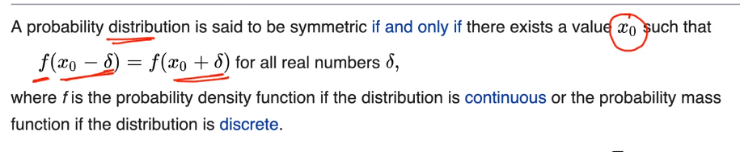

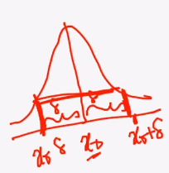

Above def states that for Symmetric distribution the Probability distribution/height at particular range on left side is similar to Probability distribution/height on right side of any point x0, where mean lies.

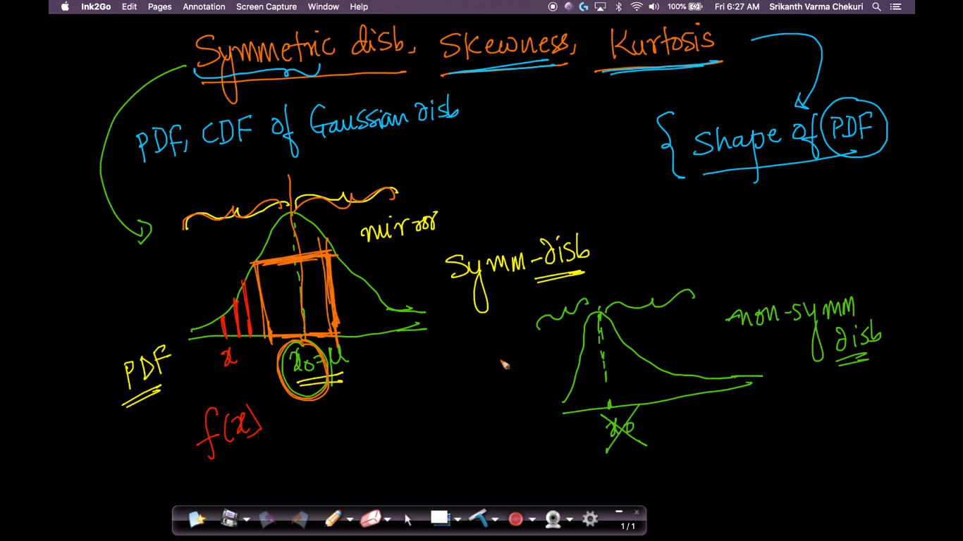

**Skewness:**

When they are displayed graphically, some distributions of data have many more observations on one side of the graph than the other.

Distributions with fewer observations on the right (toward higher values) are said to be **skewed right**; and distributions with fewer observations on the left (toward lower values) are said to be **skewed left**.

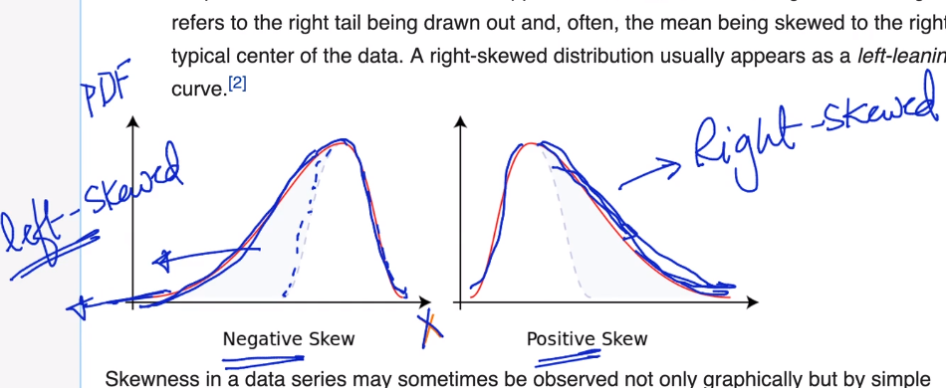

Formula for skewness is given below.

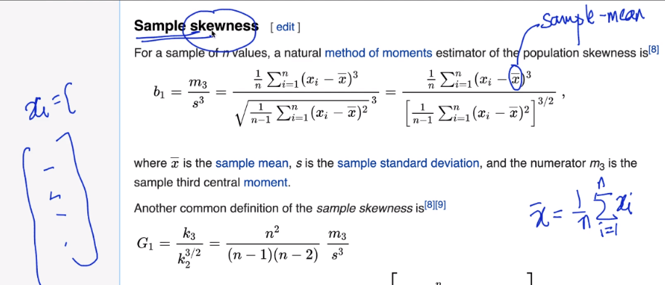

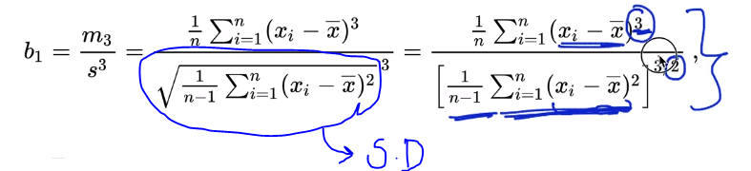

If there are two curve both having +ve skewness, then one with greater skewness have larger tail, than smaller skewness one.

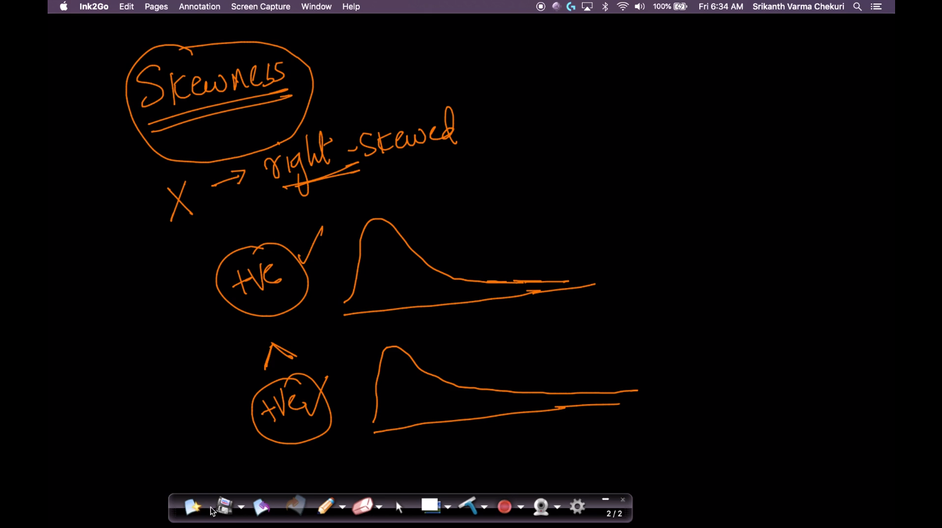

**Kurtosis:**

Kurtosis is a statistical measure that defines how heavily the tails of a distribution differ from the tails of a normal distribution. In other words, kurtosis identifies whether the tails of a given distribution contain extreme values.

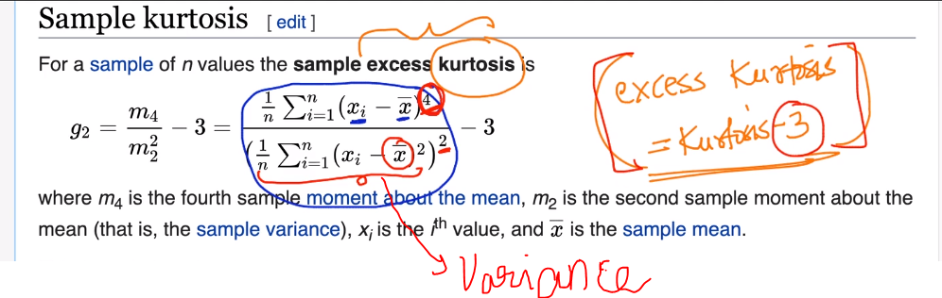

**What is Excess Kurtosis?**

An excess kurtosis is a metric that compares the kurtosis of a distribution against the kurtosis of a normal distribution. The kurtosis of a normal distribution equals 3. Therefore, the excess kurtosis is found using the formula below:

**Excess Kurtosis = Kurtosis – 3**

Excess Kurtosis means how much kurtosis is there for random variable as compare to kurtosis of gaussian distribution(kurtosis of gaussian dist is 3).

So in below figure our gaussion distributed curve is black curve, why so?, because the excess is 0 for that as gaussian’s kurtosis is 3 and excess is calculated as:

Gaussian’s kurtosis – given curve kurtosis

3-3 = 0,

Hence if excess kurtosis is 0 then it’s gaussian distribution curve.

So on basis of this we can see that for red curve the excess kurtosis is 3, that means it’s actual kurtosis is 6 (3+3)

For orange curve excess kurtosis is 2, therefore actual kurtosis is (3+2) 5

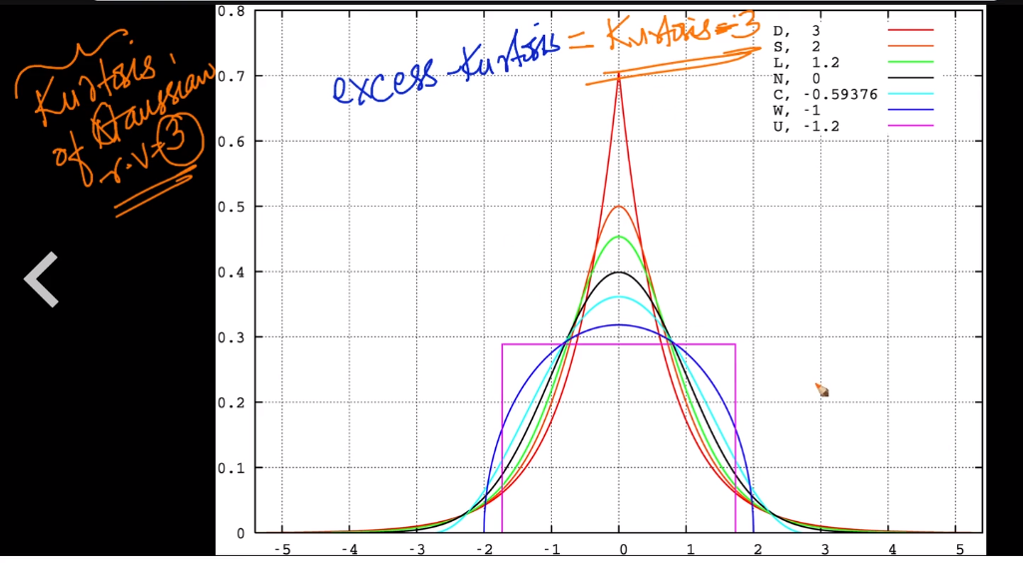

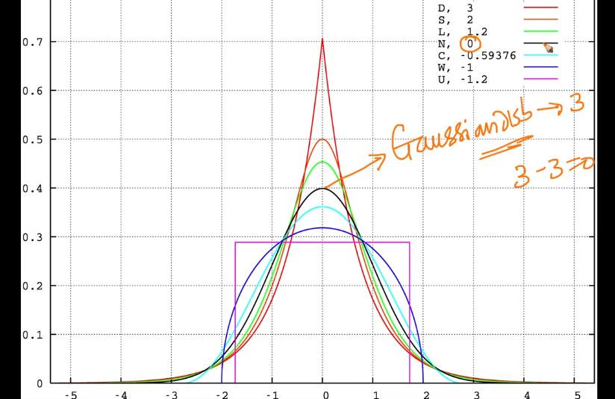

Below figure show excess kurtosis of each figure and on the basis of this we can see that as excess kurtosis is decreasing the curve’s tailedness is also decreasing, hence kurtosis also tells us the measure of tailedness, the larger the excess kurtosis, the more will be tailedness

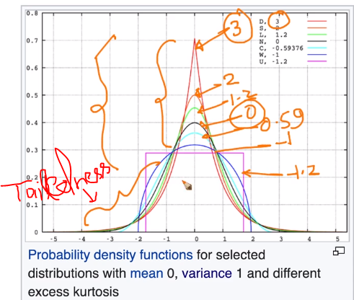

One can also says that more the excess kurtosis, the more will be peakedness, that It’s also a characterization of peakedness, but it’s wrong or mistaken, one should not derive peakedness from excess kurtosis.

**Why kurtosis is used:** 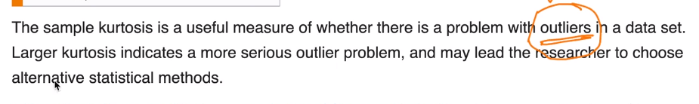

**Types of Kurtosis:**

The types of kurtosis are determined by the excess kurtosis of a particular distribution. The excess kurtosis can take positive or negative values as well, as values close to zero.

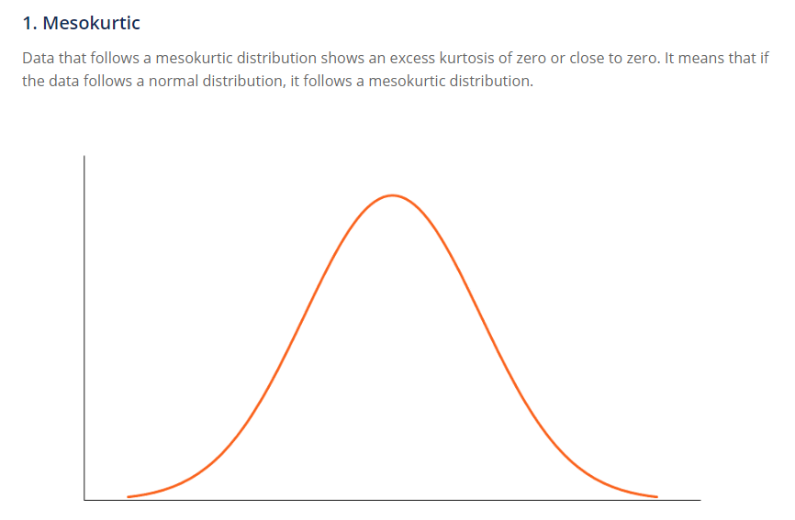

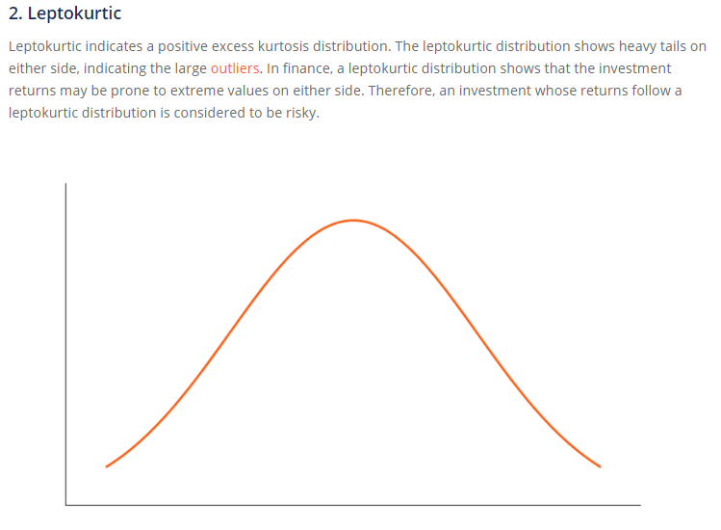

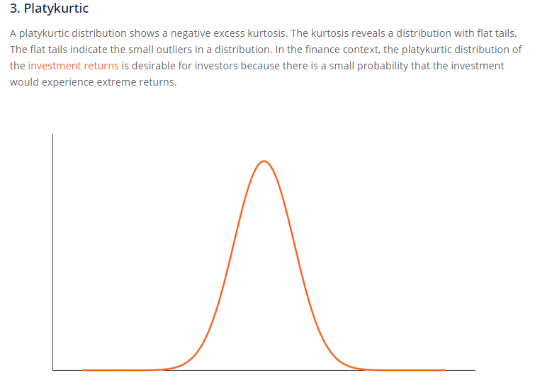

**Conclusions:**

* Skewness measures degree of symmetry while kurtosis measures degree of presence of outlier in a distribution

**Extra:**

* **Long Tail**: In [statistics](https://en.wikipedia.org/wiki/Statistics) and [business](https://en.wikipedia.org/wiki/Business), a **long tail** of some [distributions](https://en.wikipedia.org/wiki/Probability_distribution) of numbers is the portion of the distribution having a large number of occurrences far from the "head" or central part of the distribution
* **Fat tailed / heavy tailed**: A **fat-tailed distribution** is a [probability distribution](https://en.wikipedia.org/wiki/Probability_distribution) that exhibits a large [skewness](https://en.wikipedia.org/wiki/Skewness) or [kurtosis](https://en.wikipedia.org/wiki/Kurtosis), relative to that of either a [normal distribution](https://en.wikipedia.org/wiki/Normal_distribution) or an [exponential distribution](https://en.wikipedia.org/wiki/Exponential_distribution).